Build Requirements:

Tools:

* Visual Studio 2008 Professional
* Windows 7 WDK
* Windows 7 SDK

Notes:

* Add the Windows 7 WDK inc\api path to the standard include paths in VS2008.
  + In Visual Studio, select the *Tools -> Options* menu
  + Select *Projects and Solutions\VC++ Directories*
  + Select Show directories for: *Include files*
  + Add WDK api path to the **end** of the include path list.
  + Add WDK ddk path to the **end** of the include path list.

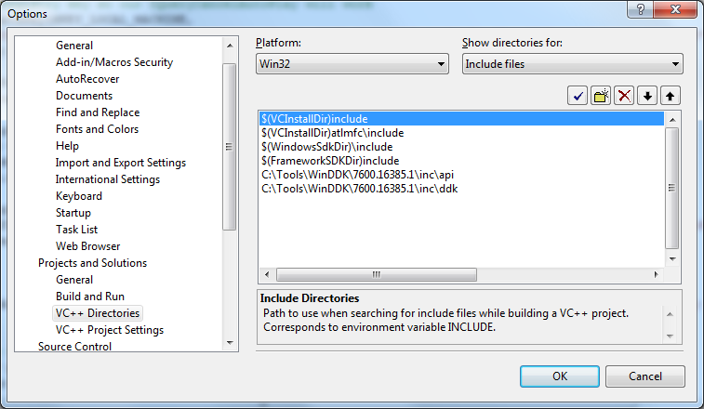

In some cases, the order of the include path may affect build result. You can try below order if you find build error caused by the lack of SDK headers:

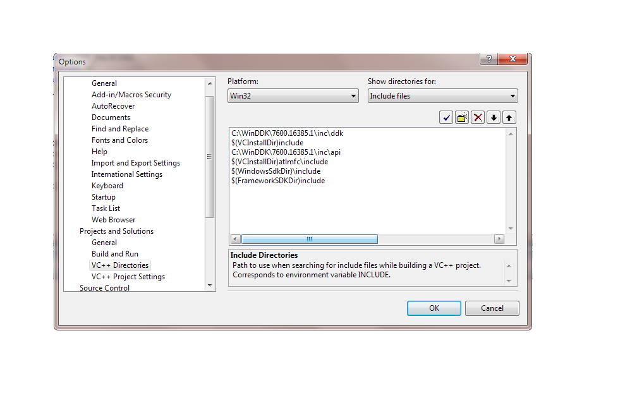

* Set $(WindowsSdkDir) and $(FrameworkSDKDir) to both refer to Windows 7 SDK.
  + - Install the latest SDK from Microsoft.
    - Navigate to *<Install Directory>\Setup* folder. Default is similar to “C:\Program Files\Microsoft SDKs\Windows\v7.1\Setup”
    - Run WindowsSdkVer.exe
    - Select latest version in drop-down menu and click *Make Current*.

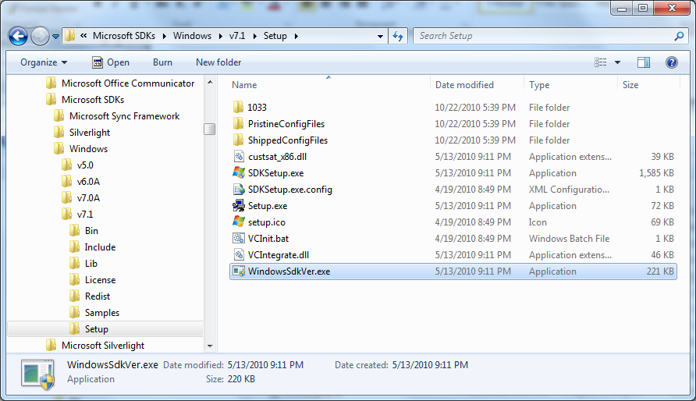

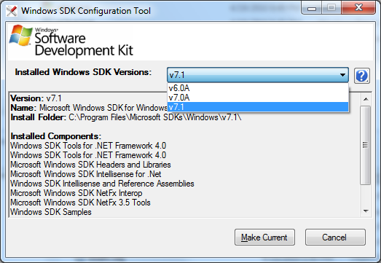

* Ensure $(WindowsSdkDir) and $(FrameworkSDKDir) both refer to Windows 7 SDK.
  + - In VS2008 Solution Explorer, right-click MfgTool project and select *Properties*.
    - Select *Configuration Properties -> C/C++ -> General*.
    - Select *Additional Include Directories*.
    - Click the … button in the *Additional Include Directories* edit box.
    - Click the *Macros>>* button.
    - Scroll through macros to verify SDK paths.

